Assessment: Lab6

Student Name: Zahi Masarwa

Lab Professor Name: Mel Sanschagrin

Lab Section Number: 303

Due Date: 03/19/21

# Understand the problem

A Program that will calculate the shipping cost of a parcel depends on the weight and shipping way plus $10

Service fee

For example, if we ship 10KG parcel with transport truck it will be calculated like this:10*0.1+10=$11

# Pseudocode

Start

Declare int select,truck,train,plane,service;

Declare double cost,costmodTruck,costmodTrain,costmodPlane, weight

declare String shipingMethod=””

Truck=1;

Train=2;

Plane=3;

Service=10;

Cost=0;

costmodTruck=0.1

costmodTrain=0.25

costmodPlane=0.75

Output “Please input the weight of the parcel to ship”

Input weight

Output “Enter 1 to ship by truck”

Output “Enter 2 to ship by train”

Output “Enter 3 to ship by plane”

Input select

Switch (select)

Case select = Truck

Cost=roundnumber (costmodTruck* weight+ Service)

Case select = Train

Cost= roundnumber (costmodTrain* weight+ Service)

Case select= Plane

Cost= roundnumber (costmodPlane * weight+ Service)

Default

Output “Invalid shipping method selected”

If cost >0

Print “Shipping by selected method costs: cost”

End

# Flowchart

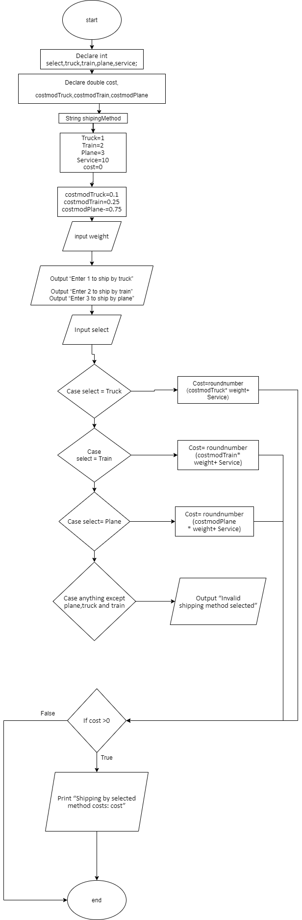

# Test Algorithm with Simple Input

|  |  |  |  |
| --- | --- | --- | --- |
| Input | Expected Output | Output | Description |
| Input weight 10  Select shipping method 1 | Please input the weight of the parcel to ship  Output “Enter 1 to ship by truck”  Output “Enter 2 to ship by train”  Output “Enter 3 to ship by plane”  Shipping by Truck costs: 11 | Output “Enter 1 to ship by truck”  Output “Enter 2 to ship by train”  Output “Enter 3 to ship by plane”  Shipping by Truck costs: 11 |  |
| Input weight A | Please input the weight of the parcel to ship  Error | Error | because I entered string I got an error in output |
| Input weight 2  Select shipping method a | Please input the weight of the parcel to ship  Invalid shipping method selected | Please input the weight of the parcel to ship  Invalid shipping method selected |  |

# Compile and Run Your Program

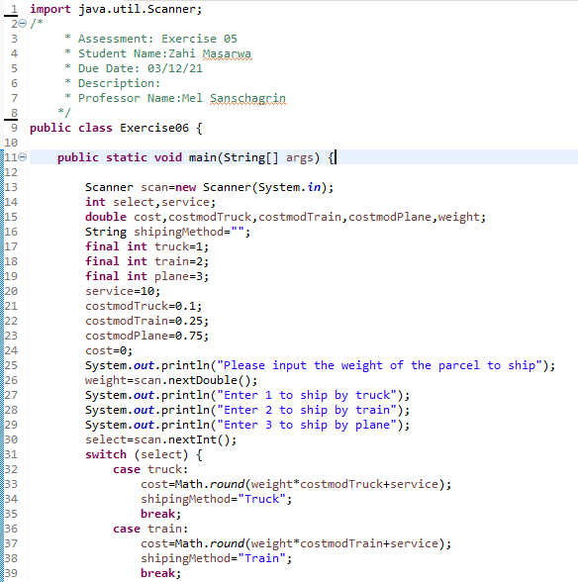

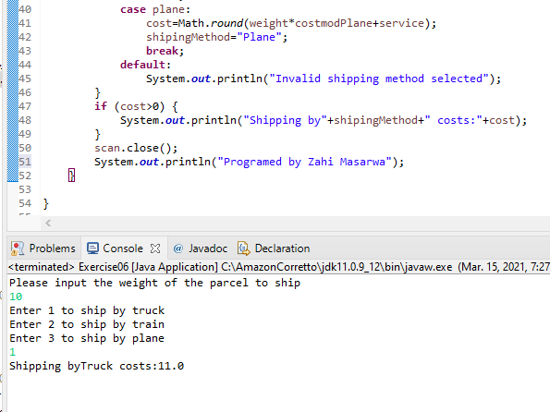

# Test Your Program

|  |  |  |  |
| --- | --- | --- | --- |
| Input | Expected Output | Output | Description |
| Input weight 10  Select shipping method 1 | Please input the weight of the parcel to ship  10  Enter 1 to ship by truck  Enter 2 to ship by train  Enter 3 to ship by plane  1  Shipping byTruck costs:11.0 | Please input the weight of the parcel to ship  10  Enter 1 to ship by truck  Enter 2 to ship by train  Enter 3 to ship by plane  1  Shipping byTruck costs:11.0 |  |
| Input weight a | Error | Error | because I entered string, I got an error in output |
| Input weight 16  Select shipping method 2 | Please input the weight of the parcel to ship  16  Enter 1 to ship by truck  Enter 2 to ship by train  Enter 3 to ship by plane  2  Shipping byTrain costs:14.0 | Please input the weight of the parcel to ship  16  Enter 1 to ship by truck  Enter 2 to ship by train  Enter 3 to ship by plane  2  Shipping byTrain costs:14.0 |  |
| Input weight 16  Select shipping method 5 | Please input the weight of the parcel to ship  16  Enter 1 to ship by truck  Enter 2 to ship by train  Enter 3 to ship by plane  5  Invalid shipping method selected | Please input the weight of the parcel to ship  16  Enter 1 to ship by truck  Enter 2 to ship by train  Enter 3 to ship by plane  5  Invalid shipping method selected |  |